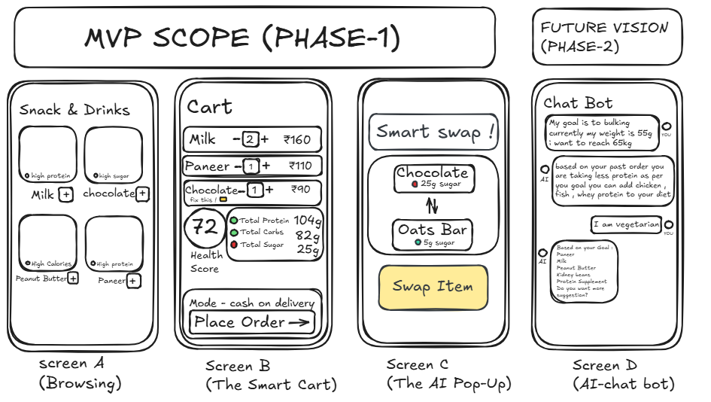

The Solution: Smart Cart Health Integration
Concept: A non-intrusive nutrition dashboard that empowers users to make healthier grocery decisions in real-time without slowing down checkout.
The 3 Core Features (MVP):
- Smart Badges (Prevention): Contextual nutrition tags (e.g., High Sugar, High Protein) displayed directly on product images during browsing.
What it solves: empowering users with instant health insights and nudges for wiser choices.

- Cart Health Score (Awareness): A dynamic score (0–100) visible in the cart. Includes a "Macro Summary" (Protein/Carbs) for fitness users.
What it solves: Avoiding customers from making impulse decisions.

- AI Smart Swaps(Action) : An algorithm that detects unhealthy items (e.g., Soda) and suggests a healthier alternative (e.g., Diet Soda) with a one-tap switch.
What it solves: Providing customers with the healthier alternative to make better food decisions.

Why are we doing this?

India’s health and wellness market is at an inflection point. Consumers, especially in urban areas, are becoming more conscious of what they eat, yet the shelves are crowded with products that promise health but deliver little more than clever marketing. At the same time, online grocery apps have become the default way for millions to shop, but their focus remains on discounts and impulse-driven engagement rather than genuine well-being.

This creates a gap — people want healthier lives, but the platforms they rely on aren’t designed to guide them there. By reimagining grocery shopping as more than a transactional experience, we can transform it into a journey of mindful consumption. Instead of nudging users toward short-term gratification, we can empower them with awareness, helping them track and understand their nutrition intake as part of everyday choices.

The vision is to blend the convenience of online grocery with the intelligence of nutrition tracking, creating a trusted companion that doesn’t just deliver food but actively supports healthier living. Over time, this approach builds habits, fosters trust, and positions us not as another delivery app, but as a partner in the pursuit of wellness.

